Indian Motorcycle PowerPlus 112 Service Schedule
These tables are pulled from the Rider’s Manual for the following MY25 bikes:

Indian Challenger
Indian Pursuit
Indian Chieftain PowerPlus
Indian Roadmaster PowerPlus

If you are consulting this document to service a newer or different PowerPlus model, we recommend you review the owner’s manual provided to you.
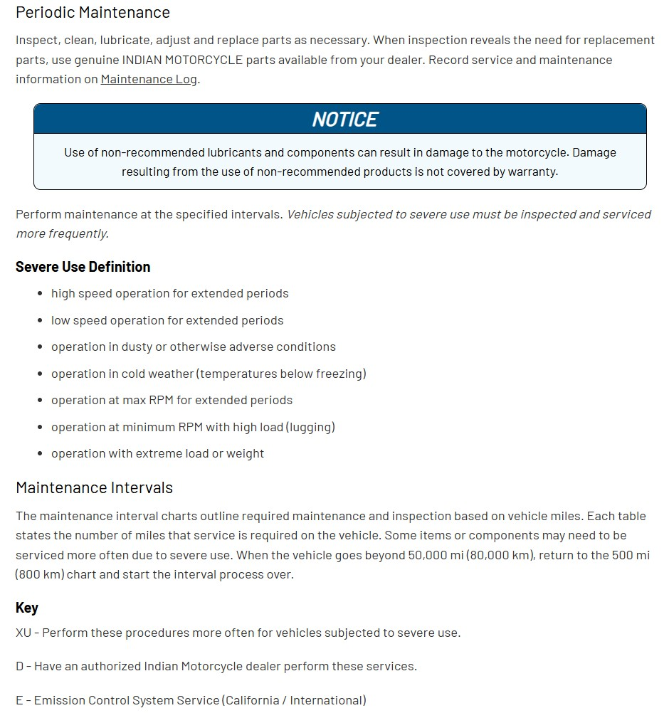

500 Miles
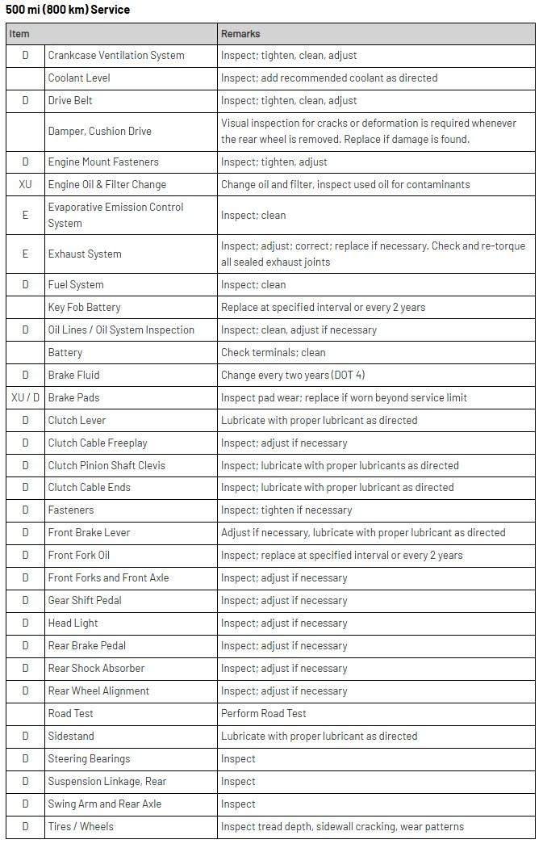

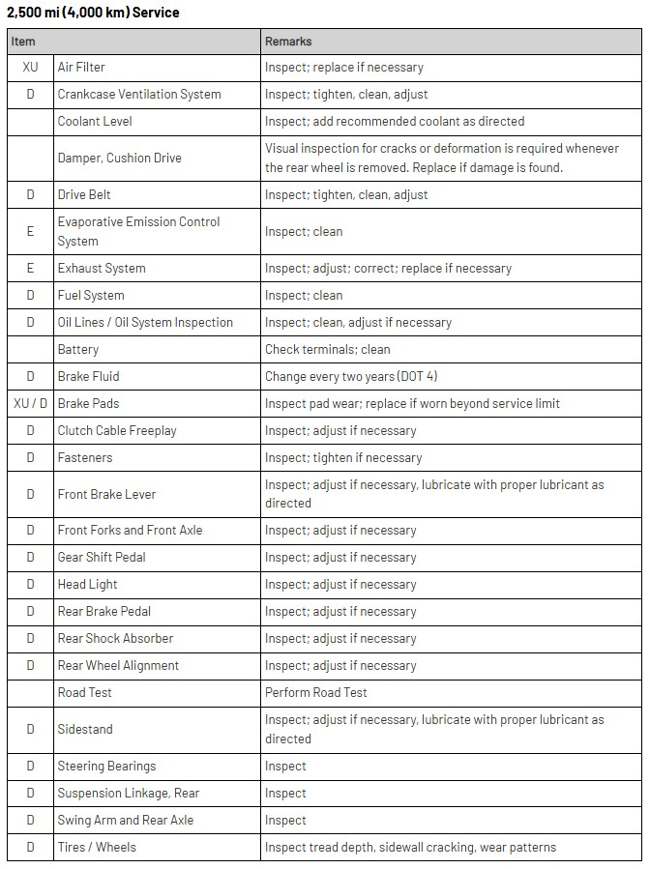
2500 Miles

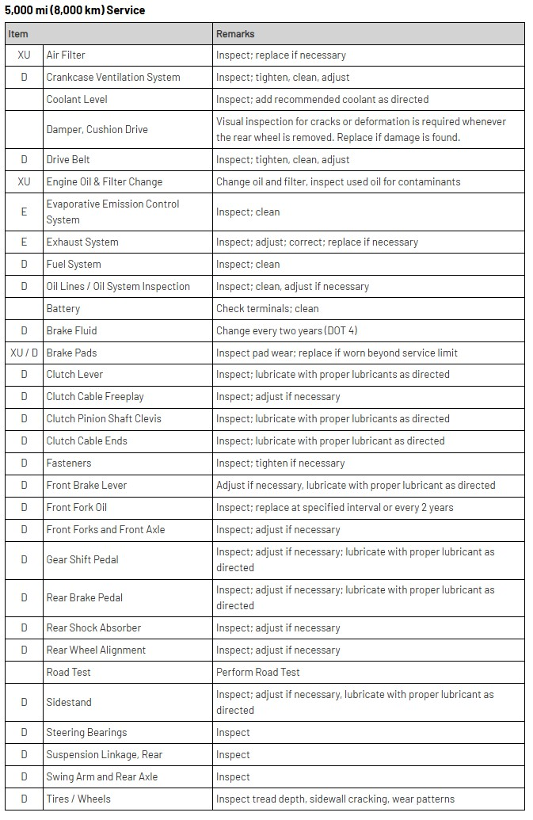
5k Miles

10k Miles
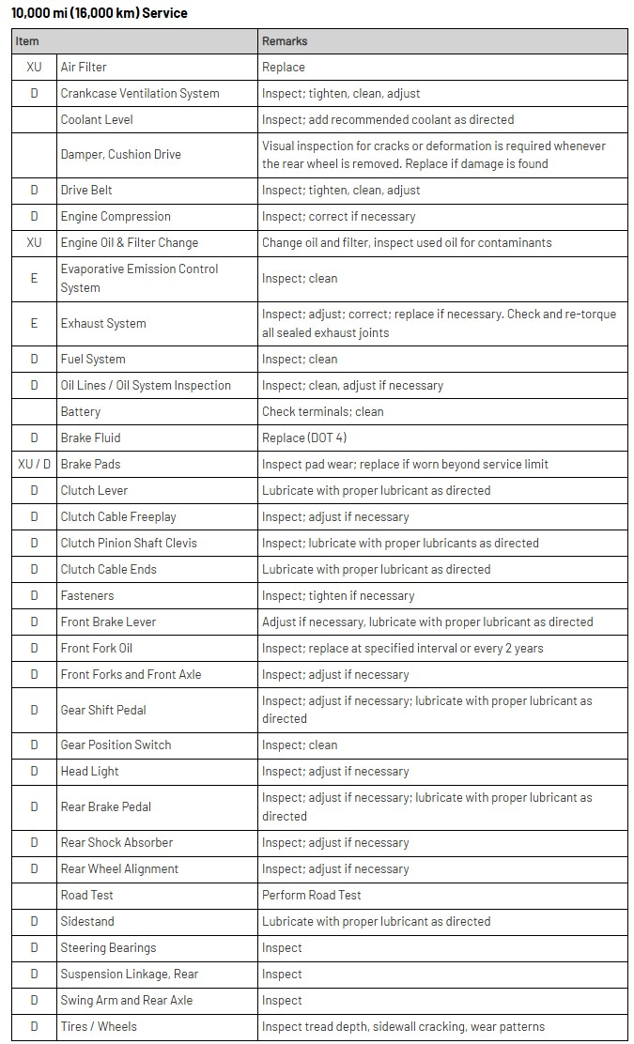

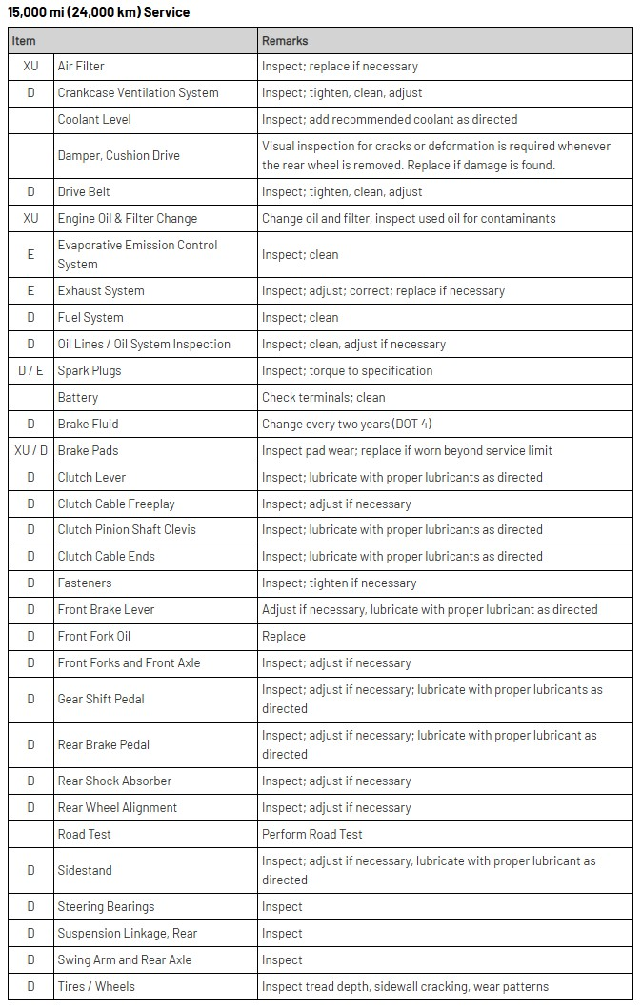
15k Miles

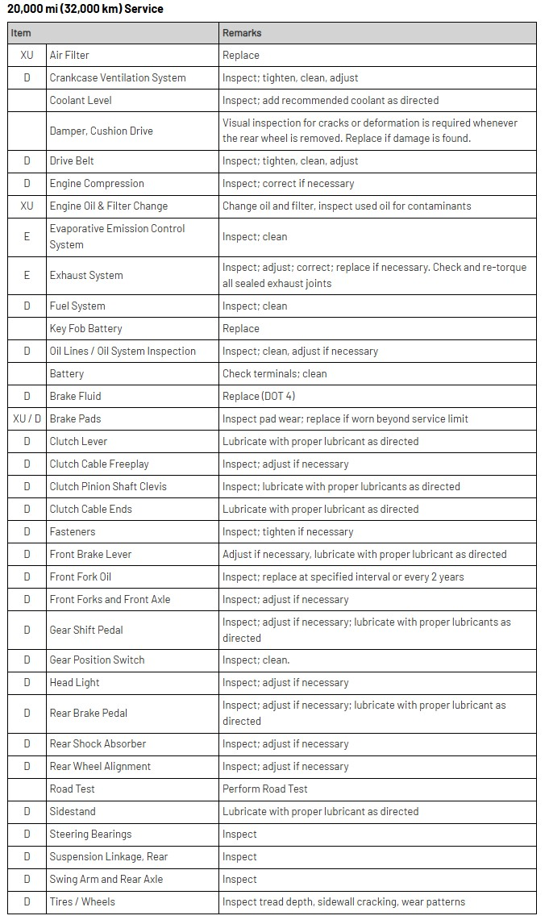
20k Miles

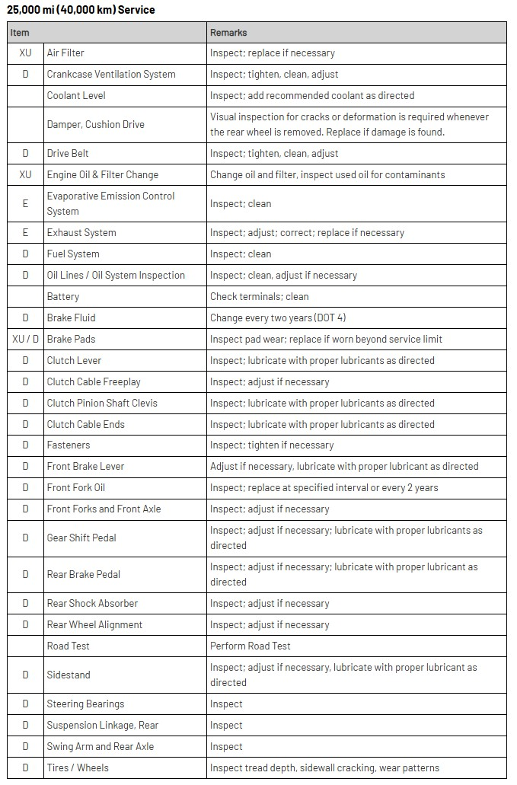
25k Miles

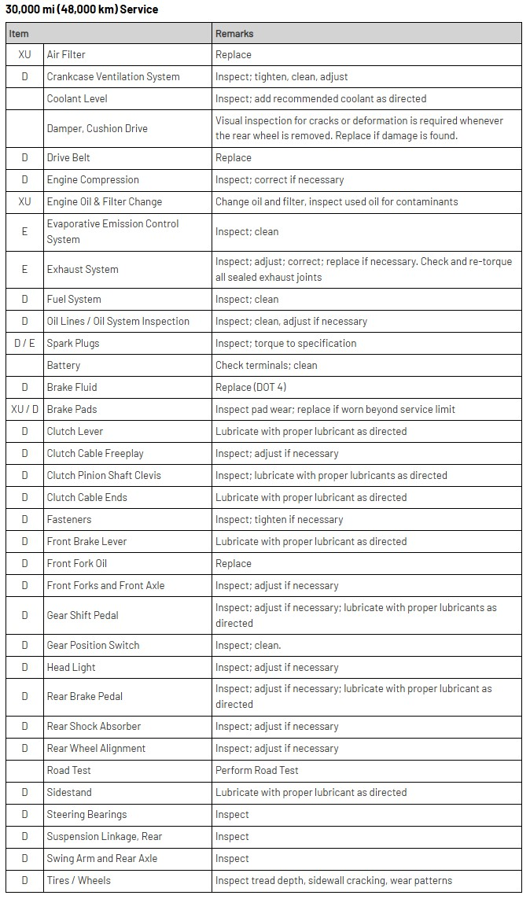
30k Miles

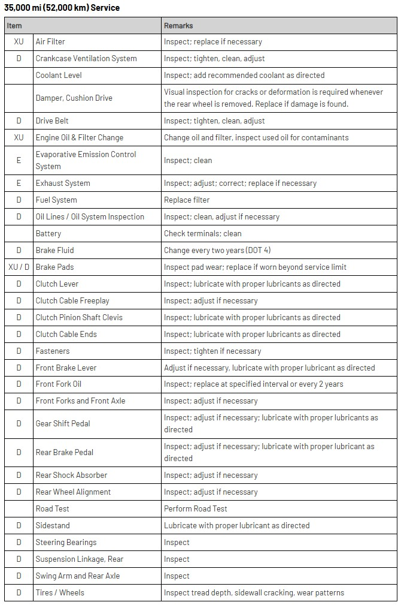
35k Miles

40k Miles
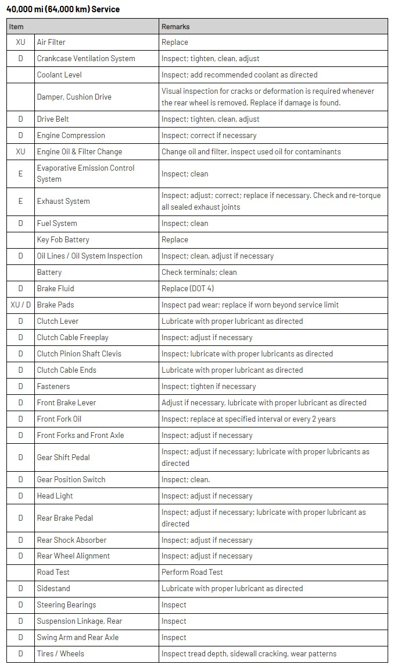

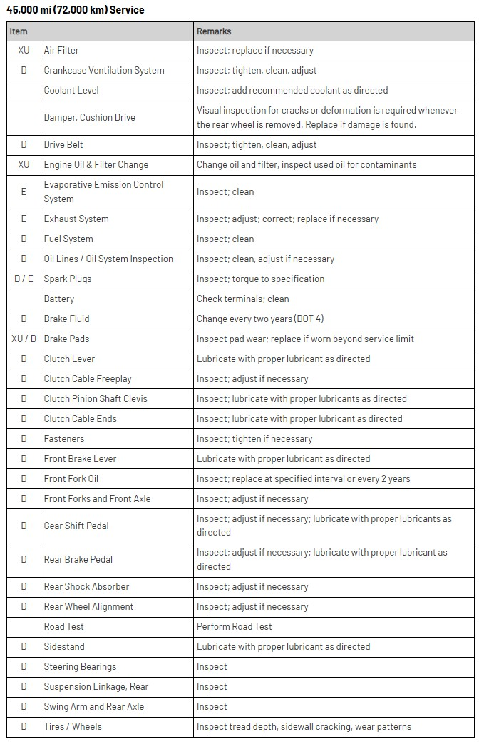
45k Miles

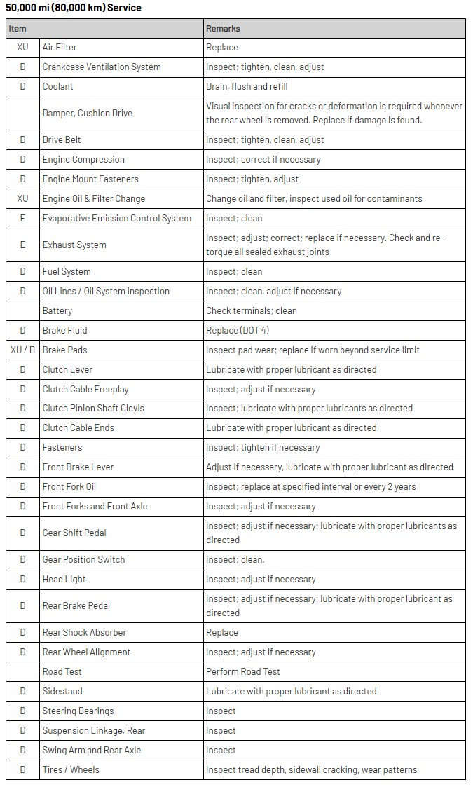
50k Miles

When the vehicle goes beyond 50,000 miles, return to the 500-mile chart and start the interval process over.

