Royal Enfield Himalayan

Periodical Maintenance
The Periodical maintenance schedule detailed below is based upon average riding conditions and indicates the Intervals at which regular inspections, adjustments, replacements and lubrications must be carried out to help maintain your Himalayan motorcycle meticulously. If in case the motorcycle is used frequently in very dusty environment / severe climatic conditions / Poor Roads / stagnant water etc., the maintenance will need to be done earlier as may be required. Contact a nearest Royal Enfield Authorized Dealer / Service Center to carry out the periodical maintenance and for any expert advice.

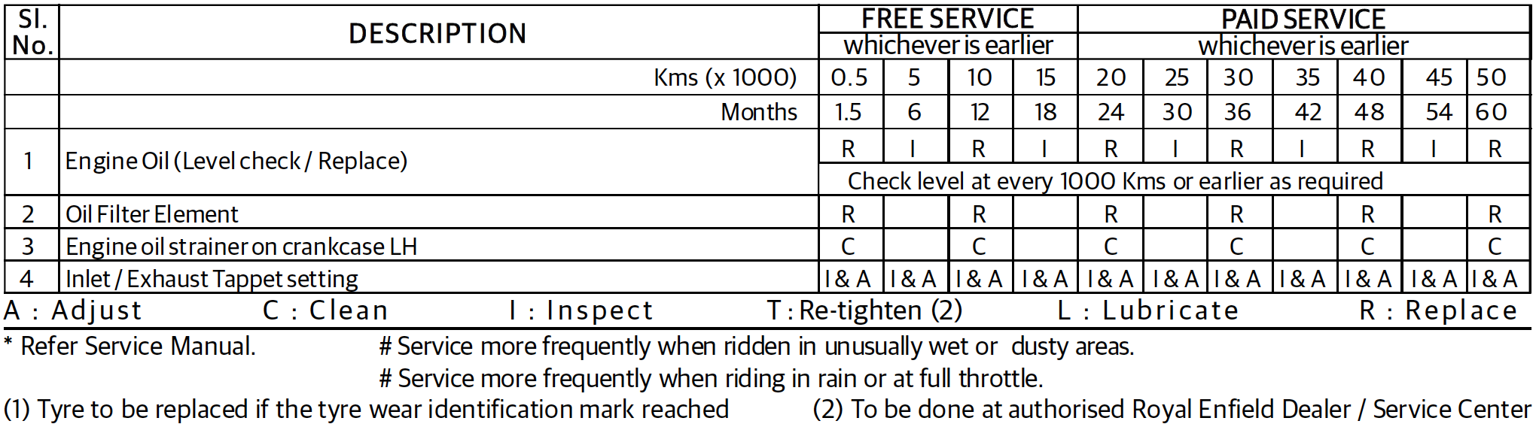
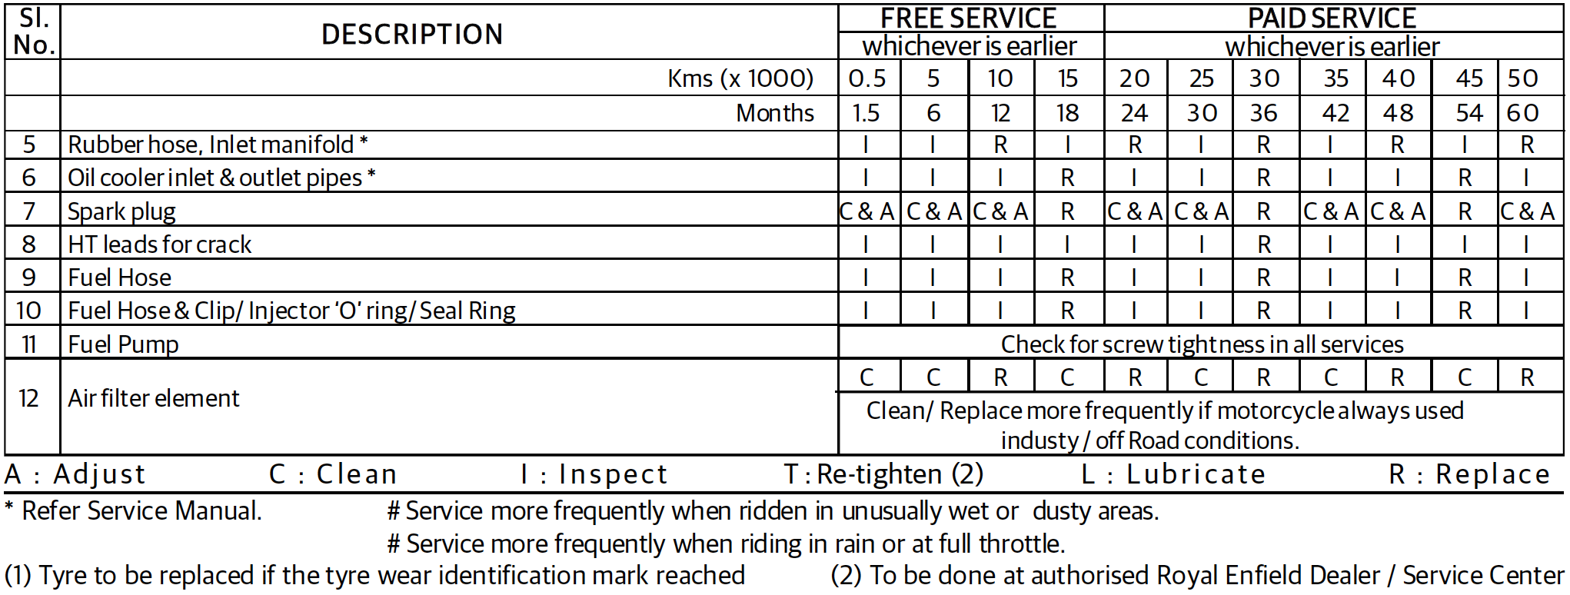
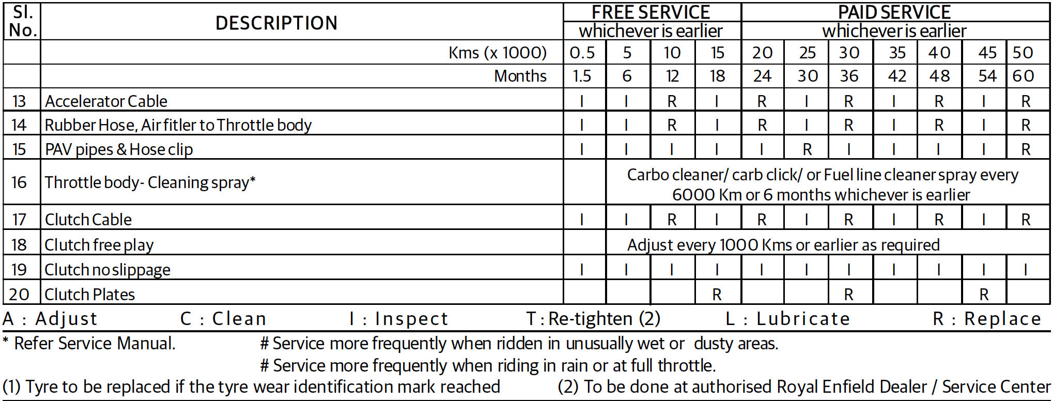
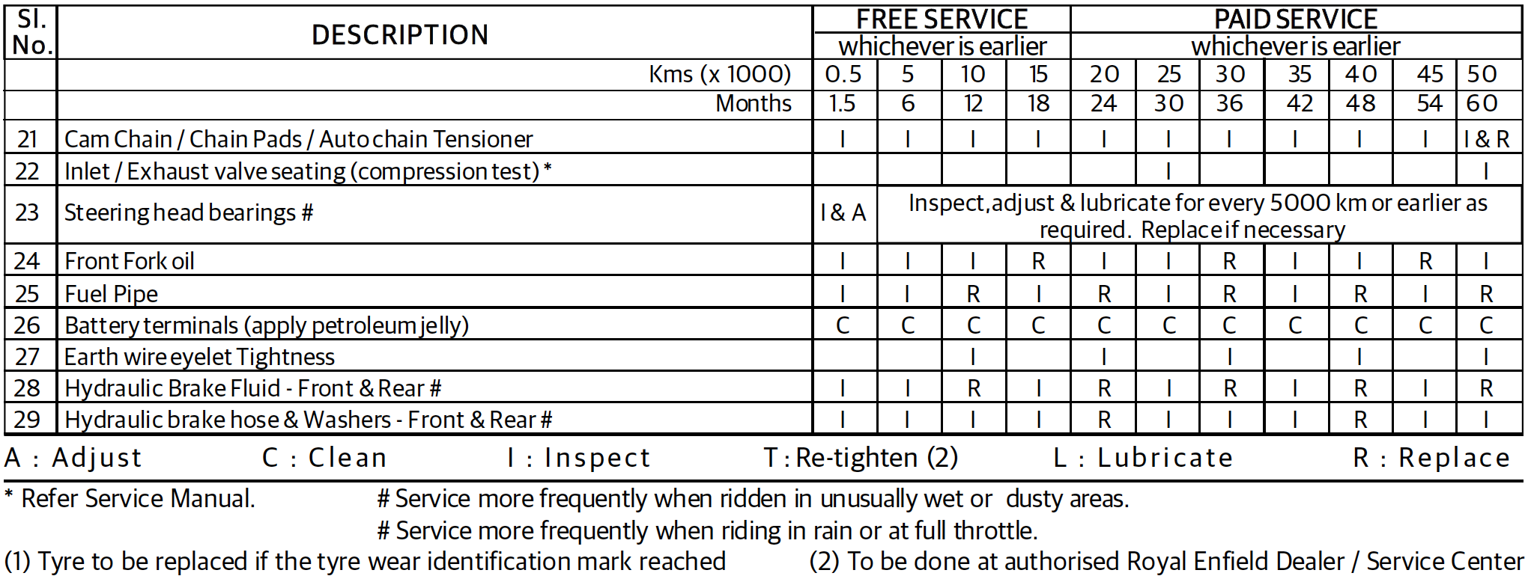
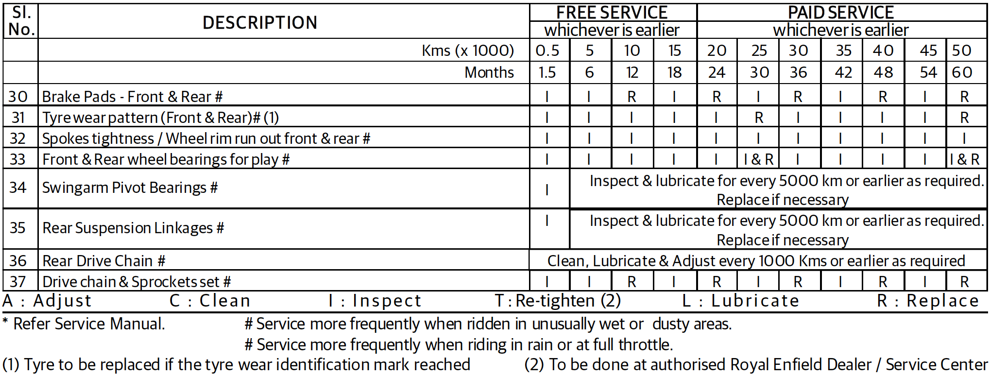
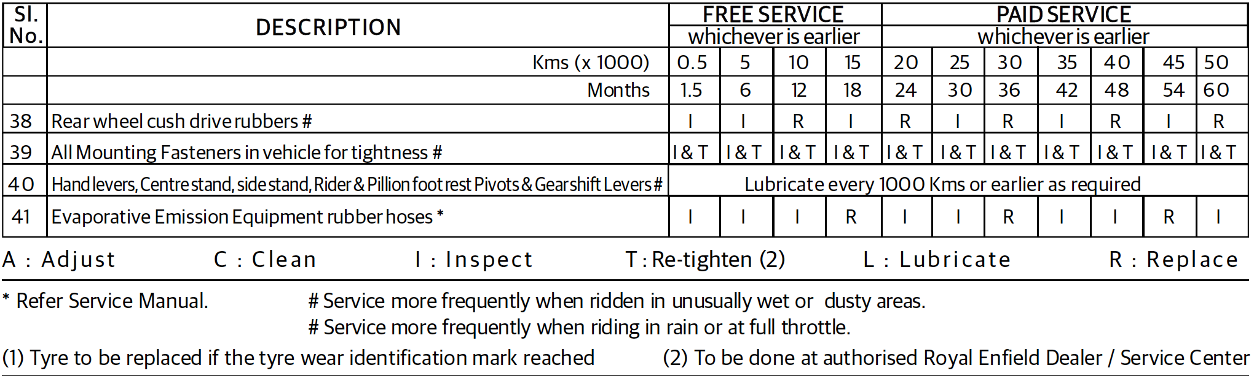

THERE IS NO FREE SERVICE, DISREGARD WHER IT SAYS FREE SERVICE IN THE CHART ABOVE!

