Royal Enfield Classic 500

Periodical Maintenance
The maintenance schedule detailed here will help you maintain your Classic 500 Motorcycle meticulously and to get a long trouble free service. The schedule provided herein is based upon average riding conditions and indicates the Kms at which regular inspections, adjustments, replacements and lubrications are to be carried out. The frequency of the maintenance must be shortened depending upon the severity of the driving condition or if the motorcycle is used in a very dusty environment. Contact the nearest Royal Enfield Authorised Dealer / Service Center for expert advice and to carry out the required maintenance.

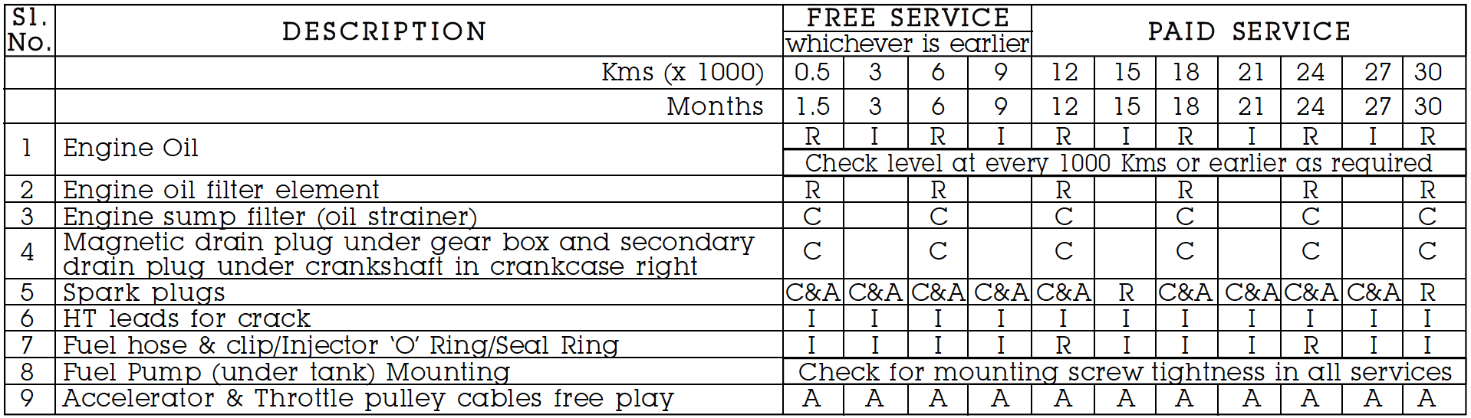
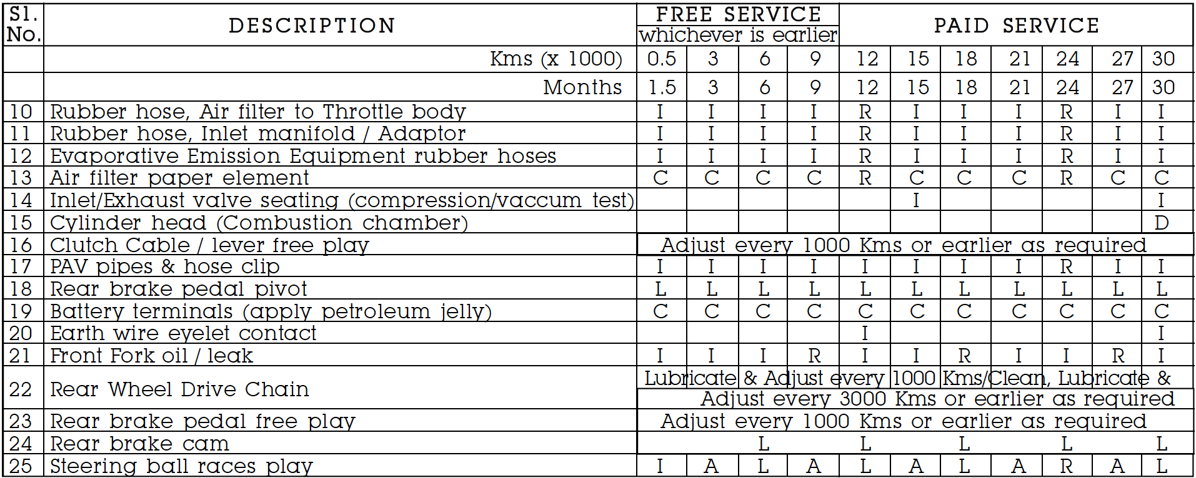
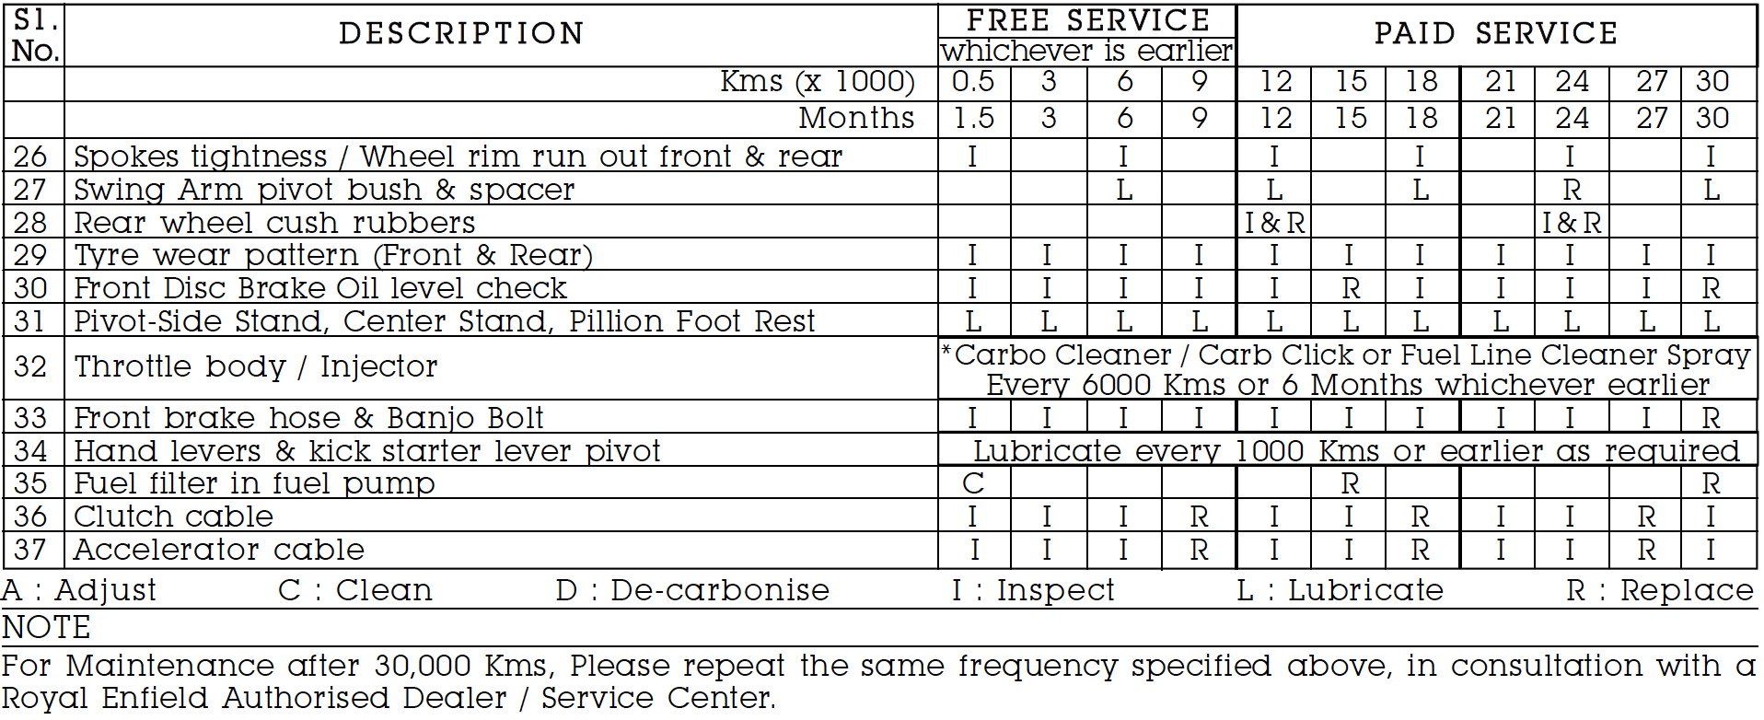

THERE IS NO FREE SERVICE, DISREGARD WHER IT SAYS FREE SERVICE IN THE CHART ABOVE!

